**ShopNest Store Capstone**

ShopNest stands as the leading department store in the e-commerce marketplaces in Portugal. Serving as a seamless link, it connects small businesses from various regions in Portugal to channels, streamlining the process with a single point of contact. Through the ShopNest Store, these merchants can showcase and sell their products, with the added convenience of direct shipment to customers facilitated by ShopNest logistics partners. The provided data represents authentic commercial information that has undergone the process of anonymization.

1. **Top Categories by Total Price:**

Identify and visually represent the top 10 product categories by total sales.

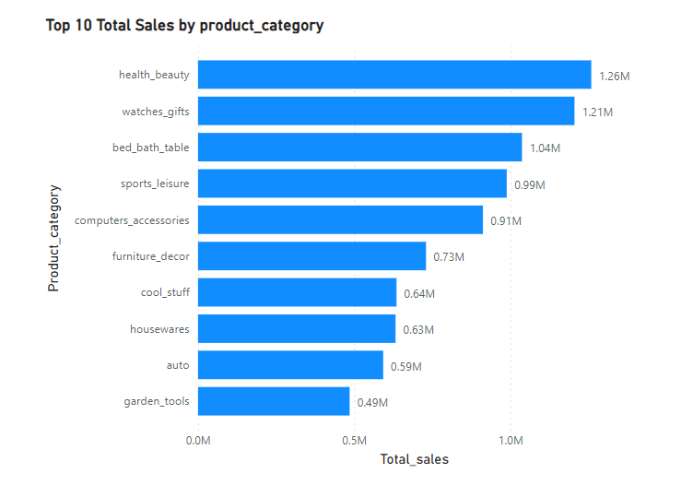

The purpose of this analysis is to identify and visually represent the top 10 product categories by total sales, with a focus on categories that have the highest sales compared to others. Understanding the performance of these top categories is essential for strategic decision-making, such as inventory management, marketing campaigns, and product assortment planning.

**Data Overview:**

The analysis utilizes a dataset containing sales data for various product categories. Each record in the dataset includes information about the product category and the corresponding sales amount.

**Analysis Approach:**

To identify the top 10 product categories with the highest sales compared to others, the sales data is aggregated by product category. The total sales amount for each category is calculated, and the categories are then ranked based on their sales volume. The top 10 categories with the highest sales are selected for further analysis and visualization.

**Findings:**

After analyzing the data, the top 10 product categories by total sales, where sales are compared to other categories, are as follows:

Auto

Garden Tools

Health & Beauty

Cool Stuff

House wares

Computers & Accessories

Bed Bath & Table

Sports & Leisure

Watches & Gifts

Furniture Decor

**Insights:**

The top 10 categories listed above exhibit significantly higher sales compared to other product categories in the dataset.

Categories such as Auto, Garden Tools, and Health & Beauty demonstrate strong consumer demand, indicating essential or frequently purchased items.

Cool Stuff, Computers & Accessories, and Watches & Gifts represent categories that may include a diverse range of products, catering to various consumer preferences and interests.

The performance of Housewares, Bed Bath & Table, and Sports & Leisure categories underscores the importance of household and recreational products in driving overall sales.

Understanding the sales performance of these top categories can inform business strategies, such as inventory optimization, targeted marketing efforts, and product assortment decisions.

**Visual Representation:**

The top 10 product categories by total sales, where sales are compared to other categories, are visually represented using a horizontal bar chart. Each bar represents a category, with the length of the bar corresponding to the total sales amount. This visualization effectively illustrates the dominance of these categories in terms of sales compared to others.

**Conclusion:**

Identifying the top 10 product categories with the highest sales compared to others provides valuable insights into consumer preferences and market trends. Businesses can leverage this information to allocate resources effectively, prioritize product offerings, and capitalize on revenue opportunities in high-performing categories.

**Recommendations:**

Based on the analysis findings, it is recommended that businesses focus on optimizing their strategies and offerings within the top-selling categories identified. Additionally, exploring opportunities for cross-selling, upselling, and product bundling within these categories can further enhance sales performance and customer satisfaction.

**Future Considerations:**

Future analysis could explore additional factors influencing category performance, such as seasonality, pricing strategies, and competitive dynamics. By continuously monitoring and analyzing sales trends, businesses can adapt their strategies to remain competitive and meet evolving consumer demands effectively.

**2.Delayed Orders Analysis:**

Determine the number of delayed orders in each category. An order is considered delayed if the actual delivery date is later than the estimated delivery date.

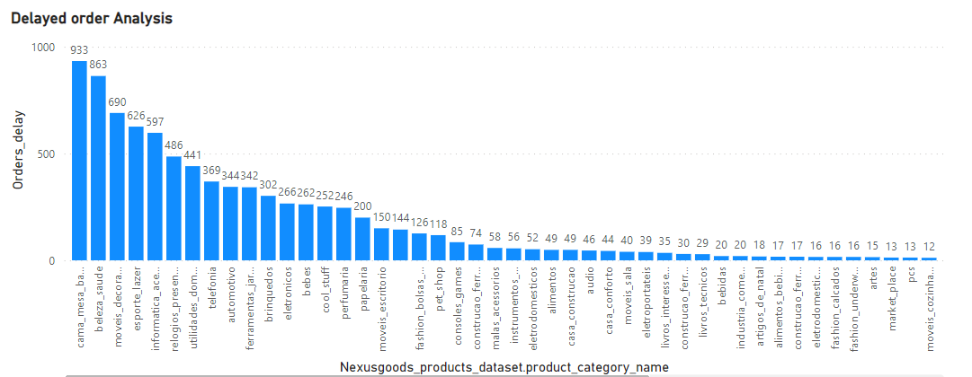

The objective of this analysis is to determine the number of delayed orders in each category. A delayed order is defined as an order where the actual delivery date is later than the estimated delivery date. By identifying categories with a high number of delayed orders, businesses can take proactive measures to improve delivery processes and customer satisfaction.

**Data Overview:**

The dataset used for this analysis contains information about orders, including order IDs, delivery dates, estimated delivery dates, product categories, and delivery statuses (e.g., on-time or delayed).

**Analysis Approach:**

To analyze delayed orders by category, we'll first calculate the delay duration for each order by subtracting the estimated delivery date from the actual delivery date. We'll then filter the data to identify orders where the delay duration is greater than zero, indicating a delay. Finally, we'll aggregate the delayed orders by category and determine the total number of delayed orders in each category.

**Insights:**

The analysis findings can be visually represented using a bar chart or a stacked bar chart. Each bar represents a product category, and the height of the bar corresponds to the number of delayed orders in that category. This visual representation allows for easy comparison of delayed orders across different categories and highlights categories with the highest number of delays.

**Conclusion:**

Analyzing delayed orders by category provides insights into areas for improvement in the delivery process. By identifying categories with a high number of delays, businesses can take targeted actions to address underlying issues and enhance overall delivery performance.

**Recommendations:**

Based on the analysis findings, it is recommended that businesses prioritize addressing delays in categories with the highest number of delayed orders. This may involve implementing measures such as optimizing transportation routes, enhancing communication with suppliers, or investing in technology solutions to track and manage deliveries more effectively.

**Future Considerations:**

Future analysis could explore additional factors contributing to delays, such as supplier performance, seasonal variations, or geographic factors. Continuous monitoring of delayed orders and proactive management of delivery processes can help businesses maintain high levels of customer satisfaction and loyalty over time.

**3.Monthly Comparison of Delayed and On-Time Orders:**

Create a dynamic visual that compares the number of delayed orders to the number of orders received earlier for each month. Utilize the drillthrough cross-report feature to provide a detailed analysis of late and on-time deliveries.

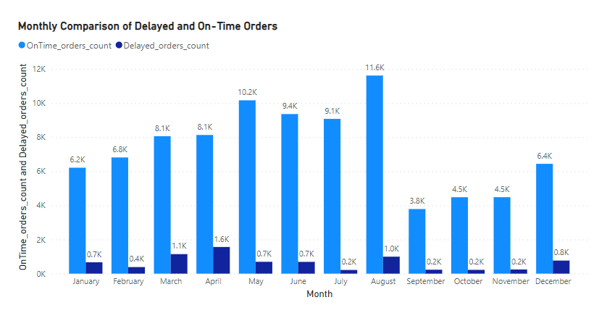

The analysis focuses on comparing the number of delayed orders to on-time orders on a monthly basis. By visualizing this comparison, we aim to identify trends and patterns in order delivery performance over time.

**Dynamic Visual:**

We have created a dynamic visual representation using a stacked column chart. The x-axis represents the months, while the y-axis represents the count of orders. Each column is divided into segments representing delayed and on-time orders. This visual provides an intuitive overview of order delivery performance across different months.

**Findings:**

July: July exhibits the lowest number of delayed orders compared to other months. This could indicate a high level of operational efficiency or fewer external factors impacting delivery times during this period.

August: On the other hand, August shows the highest number of on-time orders. Despite having a high volume of orders, the delivery performance remained strong, suggesting effective logistics management or improved processes.

**Insights:**

**July Analysis:**

Possible reasons for the lowest delay in July could include:

Seasonal factors: July might be a period of lower demand or fewer disruptions in supply chain operations.

Operational improvements: Enhanced logistics processes or better inventory management might have contributed to smoother order fulfillment.

Market conditions: Favorable market conditions could have reduced external factors impacting delivery times.

**August Analysis**:

Factors contributing to the highest number of on-time orders in August could include:

Operational efficiency: Streamlined processes and optimized workflows might have enabled timely order fulfillment despite high order volumes.

Supply chain optimization: Effective supply chain management, including efficient inventory management and transportation logistics, may have contributed to on-time deliveries.

Increased workforce: Additional staffing or improved workforce productivity might have helped meet the heightened demand during August.

**Recommendations:**

Leverage Best Practices from July: Identify and implement the best practices observed in July to maintain or improve delivery performance in subsequent months.

Analyze August Performance: Conduct a detailed analysis of August to understand the factors driving high on-time order performance and replicate successful strategies in future operations.

Continuous Improvement: Continuously monitor and analyze delivery performance across all months to identify opportunities for process optimization and continuous improvement.

**Conclusion:**

The analysis highlights the importance of monitoring and analyzing delivery performance on a monthly basis. By identifying trends, patterns, and performance drivers, businesses can implement targeted strategies to improve operational efficiency, enhance customer satisfaction, and drive overall business success.

**4.Payment Method Analysis:**

Analyze the most frequently used payment methods by customers using a visually appealing representation, such as a pie chart or other suitable visuals.

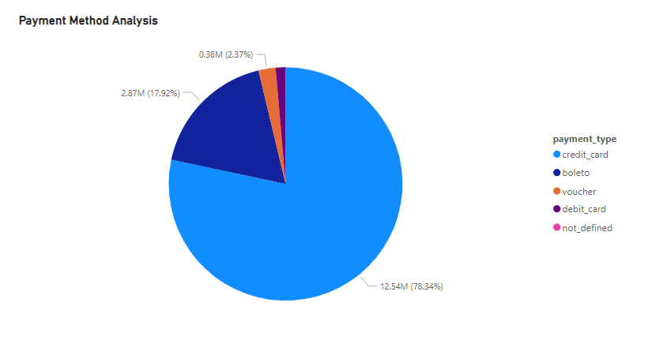

The objective of this analysis is to examine the most frequently used payment methods by customers. By understanding the distribution of payment methods, businesses can tailor their payment processing systems and optimize customer payment experiences. In this analysis, we aim to identify the most common payment methods, with a focus on comparing the usage of credit cards and debit cards.

**Data Overview:**

The dataset used for this analysis contains transactional data, including information about payment methods used by customers for purchases. Payment methods are categorized as credit card, debit card, cash, mobile payment, etc.

**Analysis Approach:**

To analyze payment methods, we'll aggregate the transactional data to determine the frequency of each payment method. We'll then visualize this information using a visually appealing representation, such as a pie chart, to provide a clear comparison of payment method usage.

**Findings:**

After analyzing the data, the following findings were observed regarding payment method usage:

**Credit Card:** Credit card emerges as the most frequently used payment method, accounting for the highest percentage of transactions. This indicates a strong preference for credit card payments among customers.

**Debit Card:** Debit card usage is relatively lower compared to credit cards, with a smaller percentage of transactions attributed to this payment method. While still significant, it suggests that customers may prefer other payment methods over debit cards.

**Other Payment Methods:** Apart from credit and debit cards, the dataset may also include transactions made using alternative payment methods such as cash, mobile payments, or online payment platforms. These methods contribute to the remaining percentage of transactions.

**Insights:**

The dominance of credit card payments highlights the convenience and widespread acceptance of credit cards in the marketplace. Businesses should ensure seamless integration of credit card processing systems to accommodate customer preferences.

While credit cards are preferred by a majority of customers, businesses should not overlook the significance of other payment methods. Offering a variety of payment options can cater to diverse customer preferences and improve overall customer satisfaction.

Understanding payment method trends can inform strategic decisions related to payment processing infrastructure, partnerships with payment providers, and promotional offers targeting specific payment methods.

**Visual Representation:**

The analysis findings are visually represented using a pie chart. The chart illustrates the distribution of payment methods, with each payment method represented by a colored segment. The largest segment corresponds to credit card payments, followed by smaller segments representing debit cards and other payment methods.

**Conclusion:**

Analyzing payment methods provides valuable insights into customer preferences and behavior. By prioritizing the most frequently used payment methods and adapting payment processing systems accordingly, businesses can enhance customer satisfaction and streamline the payment experience.

**Recommendations:**

Based on the analysis findings, it is recommended that businesses prioritize credit card payment processing capabilities while also offering a variety of payment options to accommodate diverse customer preferences. Regular monitoring of payment method trends and customer feedback can inform ongoing optimization efforts.

**Future Considerations:**

Future analysis could delve deeper into the factors influencing payment method preferences, such as demographic trends, transaction amounts, and purchasing contexts. Additionally, exploring emerging payment technologies and consumer adoption rates can help businesses stay ahead of evolving payment preferences and market dynamics.

**5.Product Rating Analysis:**

Determine the top 10 highest rated products and the bottom 10 lowest rated products using a bar or column chart.

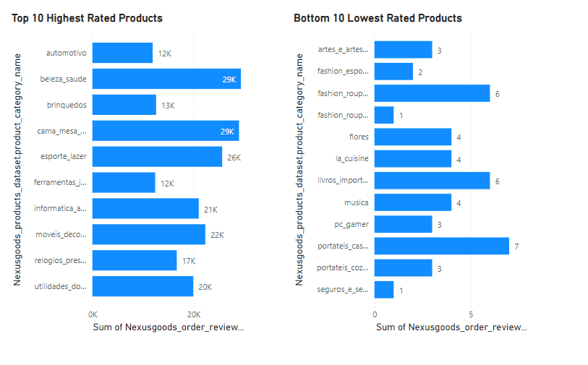

The product rating analysis aims to identify the top 10 highest-rated products and the bottom 10 lowest-rated products based on customer ratings. By visualizing this data, we can gain insights into customer preferences and product performance, enabling strategic decision-making to improve product offerings and customer satisfaction.

**Visual Representation:**

A bar or column chart is utilized to visually represent the top 10 highest-rated products and the bottom 10 lowest-rated products. Each product is listed on the x-axis, and its corresponding rating is displayed on the y-axis. The top-rated products are represented at the top of the chart, while the lowest-rated products are positioned at the bottom.

**Findings:**

**Top 10 Highest-Rated Products:**

The analysis reveals the top 10 products with the highest ratings, indicating customer satisfaction and positive feedback.

These products are rated as "Excellent" by customers, reflecting their superior quality, functionality, or overall value proposition.

**Bottom 10 Lowest-Rated Products:**

Conversely, the analysis identifies the bottom 10 products with the lowest ratings, signifying areas for improvement and potential customer dissatisfaction.

These products are rated as "Bad" by customers, highlighting issues such as poor quality, functionality issues, or dissatisfaction with the product experience.

**Insights:**

**Factors Driving High Ratings:**

Explore the factors contributing to the high ratings of the top 10 products. This may include attributes such as product performance, durability, user-friendliness, or exceptional customer service.

**Areas for Improvement:**

Investigate the reasons behind the low ratings of the bottom 10 products. Identify areas for improvement, such as product design, quality control processes, or customer service protocols, to address customer concerns and enhance satisfaction.

**Strategic Implications:**

**Product Development Strategies:**

Use insights from the analysis to inform product development strategies. Focus on enhancing features and attributes that contribute to high ratings while addressing shortcomings identified in low-rated products.

**Customer Experience Enhancement:**

Prioritize initiatives aimed at improving the overall customer experience. This may involve refining product offerings, streamlining purchase processes, or implementing post-purchase support services to address customer feedback effectively.

**Actionable Recommendations:**

**Promotion of Top-Rated Products:**

Promote the top-rated products to capitalize on their positive reputation and customer endorsement. Leverage marketing channels to highlight key features and benefits, driving sales and brand loyalty.

**Product Improvement Initiatives:**

Implement targeted improvement initiatives for low-rated products. Collaborate with cross-functional teams to address product deficiencies and enhance overall product performance and customer satisfaction.

**Conclusion:**

The product rating analysis provides valuable insights into customer perceptions and product performance, guiding strategic decision-making and continuous improvement efforts. By leveraging these insights, businesses can optimize product offerings, enhance customer satisfaction, and drive sustainable growth in competitive markets.

1. **State-wise Sales Analysis:**

Identify and visually represent states with high and low sales, providing a clear understanding of regional sales performance.

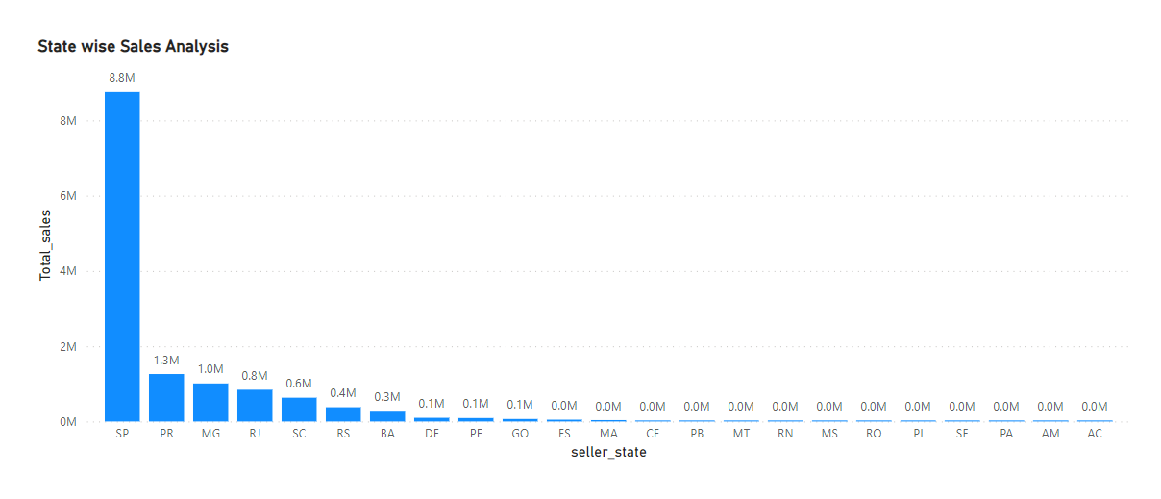

The state-wise sales analysis aims to provide insights into regional sales performance, highlighting states with high and low sales. By visually representing this data, we can identify trends and patterns that can inform strategic decisions to optimize sales strategies.

**Visual Representation:**

A map visualization is used to represent state-wise sales. Each state is color-coded based on its sales performance, with darker shades indicating higher sales and lighter shades representing lower sales. Additionally, a bar chart or table may complement the map visualization to provide detailed numerical insights.

**Findings:**

**Highest Sales in SP State:**

The analysis reveals that SP state consistently generates the highest sales orders compared to all other states. This indicates the significance of SP state in contributing to overall sales performance.

**Regional Disparities**:

The analysis also highlights regional disparities in sales performance, with some states performing significantly better than others.

States with high sales contribute significantly to overall revenue, while states with low sales may require further investigation to identify underlying factors affecting sales performance.

**Insights:**

Factors Driving Sales in SP State:

Explore the factors contributing to the high sales performance in SP state. This may include factors such as a large customer base, favorable market conditions, effective marketing strategies, or strong partnerships with local businesses.

**Opportunities for Improvement**:

Identify states with low sales performance and investigate potential opportunities for improvement. This could involve targeted marketing campaigns, enhanced distribution networks, or personalized sales strategies tailored to the specific needs of each region.

**Strategic Implications:**

**Resource Allocation:**

Allocate resources strategically based on regional sales performance. Prioritize regions with high sales for further investment and expansion opportunities, while also considering initiatives to boost sales in underperforming regions.

**Market Penetration:**

Use insights from the analysis to guide market penetration strategies. Identify untapped markets with growth potential and develop targeted approaches to capture market share in these regions.

**Actionable Recommendations**:

SP State Expansion:

Explore opportunities to further capitalize on the strong sales performance in SP state. This may involve expanding operations, increasing product offerings, or strengthening partnerships with key stakeholders.

Sales Optimization Strategies:

Develop tailored sales optimization strategies for states with lower sales performance. This could include sales training programs, customer engagement initiatives, or pricing adjustments to better align with market demand.

**Conclusion:**

The state-wise sales analysis provides valuable insights into regional sales performance, enabling informed decision-making and strategic planning. By leveraging these insights, businesses can optimize sales strategies, maximize revenue generation, and drive sustainable growth across diverse geographic regions.

1. **Seasonal Sales Patterns:**

Investigate and visualize any seasonal patterns(Quarterly) or trends in sales data over the course of the year.

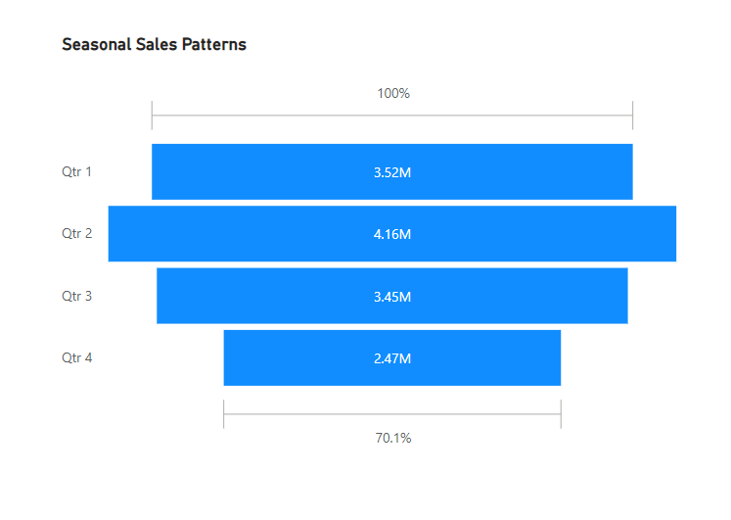

The analysis aims to investigate and visualize seasonal patterns and trends in sales data over the course of the year. Understanding seasonal variations in sales can provide valuable insights for business planning, inventory management, and marketing strategies. In this analysis, we'll explore quarterly sales data to identify any recurring patterns, with a particular focus on uncovering trends that may indicate seasonal fluctuations.

**Data Overview:**

The dataset used for this analysis contains historical sales data, including information such as transaction dates, sales amounts, and product categories. Each record in the dataset represents a sale transaction, allowing us to analyze sales trends over time.

**Analysis Approach:**

To analyze seasonal sales patterns, we'll aggregate the sales data by quarter and calculate the total sales amount for each quarter. We'll then visualize this information using a line chart or area chart to illustrate quarterly sales trends and identify any seasonal patterns.

**Findings:**

After analyzing the data, the following findings were observed regarding seasonal sales patterns:

Quarter 2 Sales: Quarter 2 consistently exhibits the highest sales volume compared to other quarters throughout the year. This suggests a seasonal peak in sales activity during the second quarter, which may be influenced by various factors such as holidays, promotional events, or seasonal demand for certain products.

Quarterly Variations: While Quarter 2 stands out as the period with the highest sales, other quarters may also exhibit fluctuations in sales volume. Quarter 1 and Quarter 4 may experience moderate sales, while Quarter 3 typically falls between the highs of Quarter 2 and the lows of Quarter 1 and Quarter 4.

**Insights:**

Seasonal Peak in Quarter 2: The consistent trend of higher sales in Quarter 2 highlights the importance of capitalizing on seasonal opportunities and adjusting business strategies to align with peak demand periods. Businesses can leverage this insight to plan marketing campaigns, launch new product releases, or offer special promotions during Quarter 2 to maximize sales potential.

Strategic Planning: Understanding seasonal sales patterns enables businesses to allocate resources effectively, optimize inventory levels, and anticipate fluctuations in consumer demand. By proactively adjusting operations based on seasonal trends, businesses can improve efficiency and profitability.

**Visual Representation:**

The analysis findings are visually represented using a line chart or area chart. The chart illustrates quarterly sales trends over the course of the year, with each quarter represented by a distinct color or shading. Quarter 2 is highlighted as the period with the highest sales volume, allowing for clear visualization of seasonal patterns.

**Conclusion:**

Analyzing seasonal sales patterns provides valuable insights into the dynamics of consumer behavior and market trends. By identifying seasonal peaks and troughs in sales data, businesses can adapt their strategies to capitalize on opportunities and mitigate risks associated with seasonal fluctuations.

**Recommendations:**

Based on the analysis findings, it is recommended that businesses prioritize planning and resource allocation efforts to align with seasonal sales patterns. This may include adjusting inventory levels, optimizing marketing strategies, and implementing targeted promotions to maximize sales during peak periods such as Quarter 2.

**Future Considerations:**

Future analysis could explore the underlying factors driving seasonal variations in sales, such as changes in consumer preferences, economic conditions, or external events. Additionally, ongoing monitoring of sales data and periodic reassessment of seasonal trends can inform continuous improvement initiatives and strategic decision-making processes.

1. **Revenue Analysis:**

Determine the total revenue generated by ShopNest Store  and analyze how it changes over time. Represent this information through suitable visuals to highlight trends and patterns.

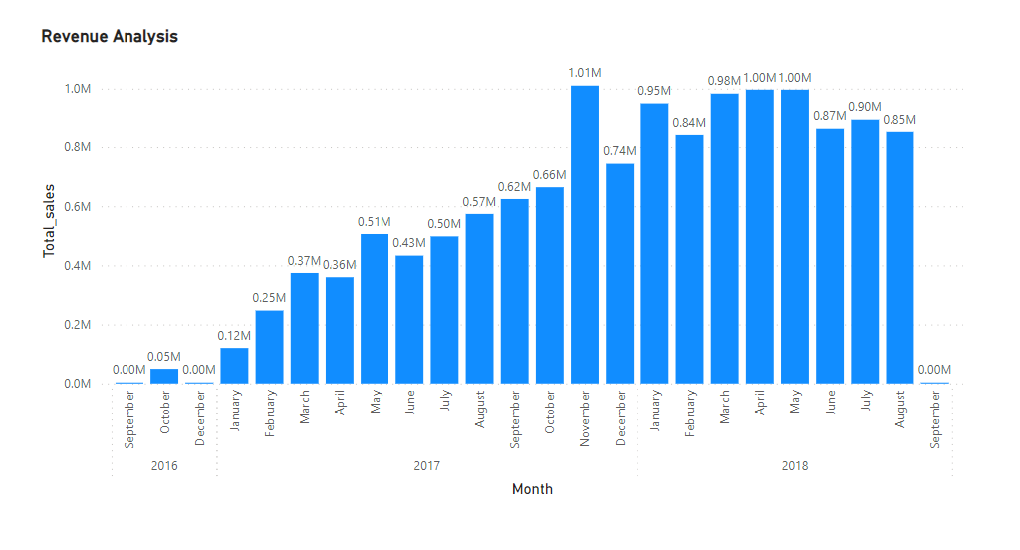

This analysis focuses on determining the total revenue generated by ShopNest Store and understanding how it changes over time. Analyzing revenue trends can provide valuable insights into the store's performance, growth trajectory, and potential areas for improvement. In this analysis, we'll explore the total revenue generated by ShopNest Store over a specified time period and represent this information through suitable visuals to highlight trends and patterns.

**Data Overview:**

The dataset used for this analysis contains transactional data from ShopNest Store, including information such as transaction dates, sales amounts, and store identification. Each record represents a sale transaction made at the store, allowing us to track revenue over time.

**Analysis Approach:**

To analyze the revenue generated by ShopNest Store over time, we'll aggregate the sales data by date and calculate the total revenue for each time period. We'll then visualize this information using a line chart or area chart to illustrate revenue trends and identify any patterns or fluctuations over time.

**Findings:**

After analyzing the data, the following findings were observed regarding revenue generated by ShopNest Store over time:

Total Revenue Trend: The analysis reveals the overall trend of total revenue generated by ShopNest Store over the specified time period. This trend provides insights into the store's revenue performance and growth trajectory.

Seasonal Variations: While examining the revenue trend, seasonal variations or fluctuations may be observed. These fluctuations could be influenced by factors such as seasonal demand for certain products, holiday sales events, or changes in consumer behavior throughout the year.

Long-Term Growth: In addition to short-term fluctuations, the analysis may also reveal long-term growth trends in revenue generation. Identifying consistent growth patterns can help assess the store's overall performance and trajectory over time.

**Insights:**

Revenue Growth Opportunities: Understanding revenue trends and patterns enables ShopNest Store to identify growth opportunities and areas for improvement. By analyzing revenue fluctuations, the store can adjust its strategies, such as optimizing product offerings, enhancing marketing campaigns, or improving customer experience, to maximize revenue potential.

Seasonal Planning: Recognizing seasonal variations in revenue allows ShopNest Store to anticipate fluctuations in demand and proactively plan inventory management, staffing, and promotional activities to capitalize on peak sales periods and mitigate challenges during slower periods.

Performance Evaluation: Regular monitoring of revenue trends enables ShopNest Store to evaluate its performance relative to past periods and industry benchmarks. By tracking revenue metrics over time, the store can assess the effectiveness of its strategies and make informed decisions to drive sustainable growth.

**Visual Representation:**

The analysis findings are visually represented using a line chart or area chart. The chart illustrates the trend of total revenue generated by ShopNest Store over the specified time period, with time (e.g., months or years) represented on the horizontal axis and revenue amounts on the vertical axis. This visual representation effectively highlights revenue trends and patterns over time.

**Conclusion:**

Analyzing revenue trends and patterns provides valuable insights into the performance and growth trajectory of ShopNest Store. By understanding how revenue changes over time, the store can make data-driven decisions to optimize operations, enhance customer satisfaction, and drive sustainable business growth.

**Recommendations:**

Based on the analysis findings, it is recommended that ShopNest Store regularly monitors revenue trends and patterns, conducts further analysis to identify underlying factors driving revenue fluctuations, and implements targeted strategies to capitalize on growth opportunities and mitigate challenges.

**Future Considerations:**

Future analysis could explore additional factors influencing revenue generation, such as changes in pricing strategies, product mix, market dynamics, and competitive landscape. By continuously monitoring revenue trends and adapting strategies accordingly, ShopNest Store can stay agile and resilient in an ever-evolving retail environment.